

CMPE-277 Smartphone Application Development

Lab 3 Report

Nearby Cafés App for Android

Rajeev Patil

011451232

Department of Computer Engineering

Fall 2018

**INTRODUCTION**

This is project report for the Café Maps Android app. This app allows the user to search for nearby places. You can jump to different locations or search for cafes near your original location. Also, I have integrated various UI elements Like Toast Notifications, Dialog boxes, Fragments, intents etc. The IDE that I used for this lab is Android Studio version 3.2. For running the app, I used Android emulator to emulate a Google Pixel 2.

**PROJECT STRUCTURE**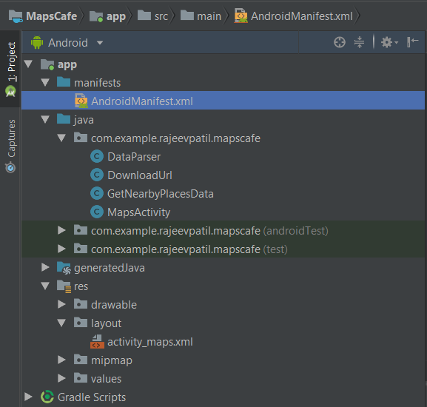

**SCREENSHOTS**

**App in the app drawer Home Screen**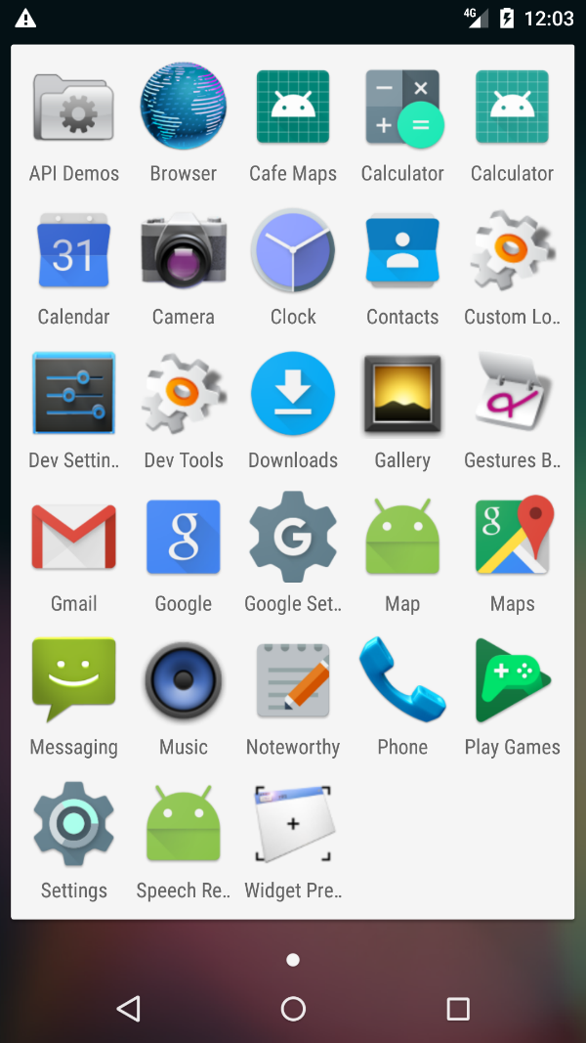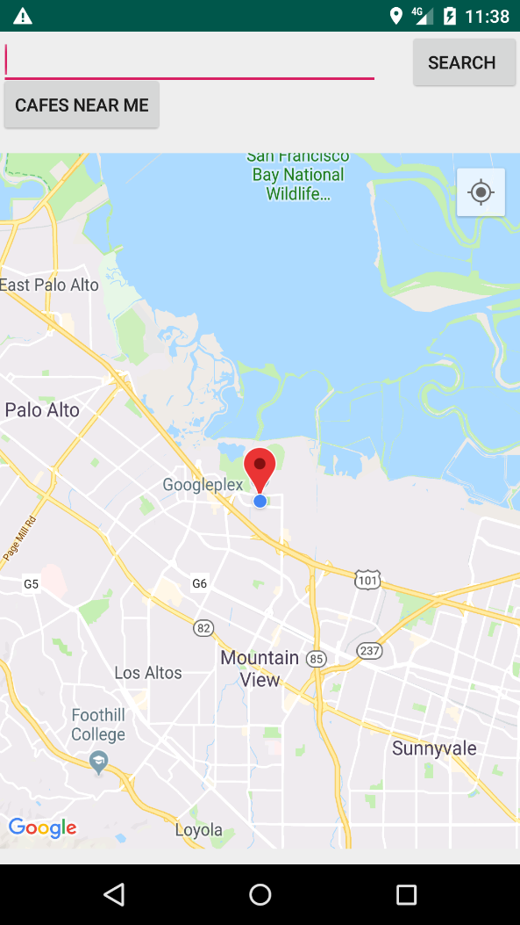

**Search for a place Press search, it takes you to there** 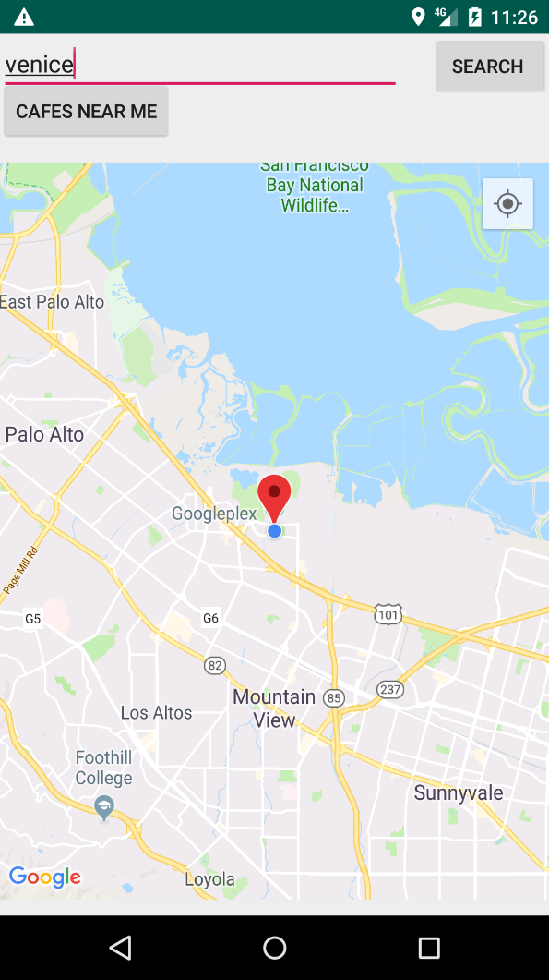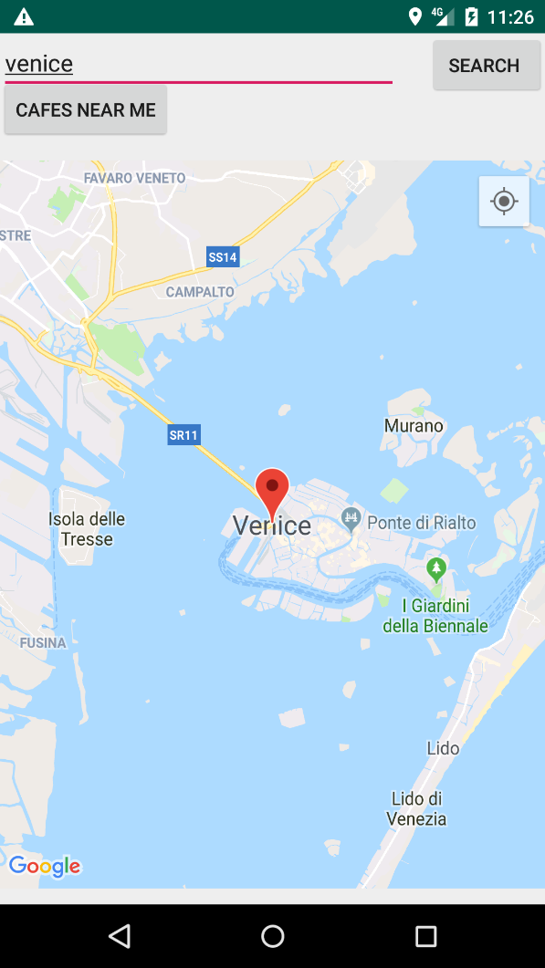

**Click on cafes near me Zoom in** 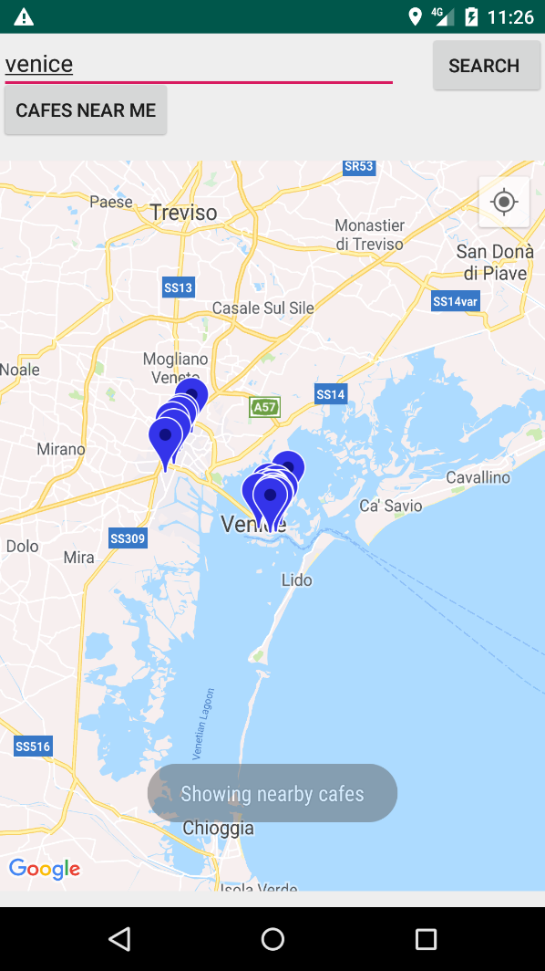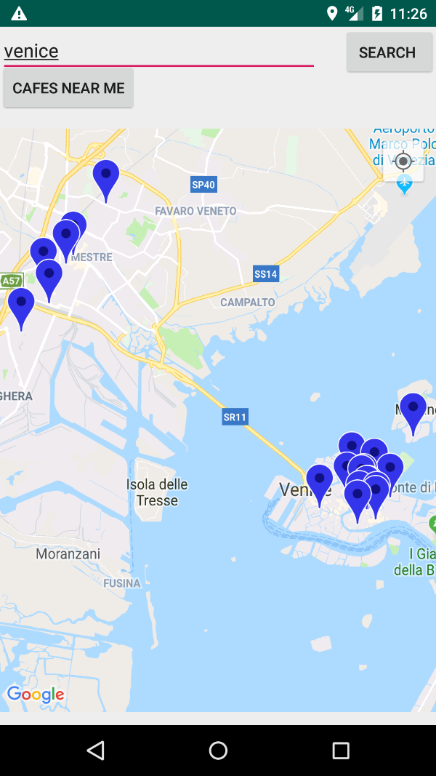

**REFERENCES**

1. Android Programming: The Big Nerd Ranch Guide (By: B. Phillips, C. Stewart, B. Hardy and K. Marsicano)
2. <https://developer.android.com>
3. Slides and material of Dr. Hungwen Li
4. <https://www.youtube.com/watch?v=_Oljjn1fIAc> Google Maps API nearby places tutorial
5. <https://cloud.google.com/maps-platform/>
6. <https://developers.google.com/maps/documentation>
7. <https://developers.google.com/maps/documentation/android-api/intro>
8. <https://developer.android.com/training/material>
9. <https://github.com/lightSky/Awesome-MaterialDesign>